YUVA INTERN
WEEK 2 INTERNSHIP TASK
Customer Behavior Analysis and Segmentation
Retail eCommerce Data Analyst Internship
Item | Details
Intern | Chadaram Jithyasree
Internship Period | 08 August 2026 – 19 September 2026
Task | Week 2: Customer Behavior Analysis and Segmentation
Mode | Remote
Primary Tools Used | Python (pandas, scikit-learn, matplotlib), Excel, Power BI
Prepared | August 2026
Prepared using a simulated customer dataset built on publicly documented industry benchmarks and segmentation theory.

Document Control
Field | Information
Document title | Customer Behavior Analysis and Segmentation
Internship role | Retail eCommerce Data Analyst
Task duration | Week 2
Objective | Build a segmentation framework and simulate customer data to identify behavioral clusters and actionable marketing strategies.
Data principle | Simulated dataset (n = 2,000) generated from publicly documented retail eCommerce benchmarks; no proprietary or personal data used.
Deliverable | Professional DOC report with methodology, segmentation framework, simulated analysis, visuals, and marketing recommendations.

Executive Summary
This report develops a customer segmentation framework for a retail eCommerce platform and demonstrates it using a simulated dataset of 2,000 customers built on publicly documented industry benchmarks and established segmentation theory. The objective is to identify distinct behavioral groups among customers so that marketing, retention, and product decisions can be tailored to each group rather than applied uniformly.
The analysis combines two complementary approaches: RFM (Recency, Frequency, Monetary) scoring, a widely used retail analytics technique, and an independent K-Means clustering model applied to the same behavioral variables. Both approaches converge on a consistent picture — a small group of highly engaged, high-value customers, a large base of moderately engaged regulars, and a meaningful tail of at-risk or dormant customers who represent a retention opportunity.
Seven RFM-based segments were identified: Champions, Loyal Customers, Big Spenders, New Customers, Needs Attention, At-Risk Customers, and Lost Customers. Champions and Loyal Customers together represent 37.8% of the customer base but disproportionately drive revenue, while At-Risk and Lost Customers together represent 19.6% of the base and show cart abandonment rates above the Baymard industry benchmark of 70.22%. The report closes with segment-specific marketing recommendations and a discussion of the limitations of using simulated data.

Table of Contents
- Introduction and Objective
- Research: Customer Segmentation Methodologies
- Segmentation Framework Development
- Simulated Dataset and Methodology
- Segmentation Analysis and Findings
- Segment Profiles and Interpretation
- Marketing Strategy Recommendations
- Limitations of the Simulated Approach
- Conclusion and Key Insights
- References

1. Introduction and Objective
Customer segmentation is the practice of dividing a customer base into groups that share similar characteristics or behaviors, so that marketing, retention, and service strategies can be tailored to each group rather than applied uniformly. In eCommerce specifically, segmentation typically draws on three categories of signals: who the customer is (demographics), what they buy and how often (purchasing patterns), and how they interact with the platform (digital behavior).
The objective of this task is to design a segmentation framework grounded in established retail analytics methodology, and to demonstrate it using a simulated customer dataset built on publicly documented benchmarks rather than proprietary company data. The output is intended to show how an analyst would approach segmentation in a real eCommerce setting: defining criteria, building or acquiring data, applying a segmentation method, interpreting the resulting groups, and translating those groups into marketing action.

1.1 Why segmentation matters
Treating all customers identically overlooks large differences in value and behavior. A small number of highly engaged customers often account for a disproportionate share of revenue, while a larger group of low-engagement or lapsed customers requires a different kind of attention — win-back offers rather than loyalty rewards, for example. Segmentation makes these differences visible and measurable, turning a single undifferentiated customer list into a set of groups the business can act on.

2. Research: Customer Segmentation Methodologies
Established retail eCommerce practice segments customers along several dimensions, often used in combination rather than isolation. The table below summarizes the main categories referenced for this task.
Segmentation type | Example parameters | Primary business use
Demographic | Age, gender, geographic region | Broad targeting, localization, product-fit inference
Purchasing pattern (RFM) | Recency, frequency, monetary value | Identifying high-value, loyal, at-risk and lapsed customers
Digital behavior | Device used, acquisition channel, browsing/cart activity | Channel optimization, UX and funnel improvements
Psychographic / preference | Product category preference, brand affinity | Personalization and cross-sell targeting
Value-based | Customer lifetime value (CLV), average order value | Prioritizing retention and service investment

2.1 Demographic factors
Demographic segmentation groups customers by attributes such as age, gender, and geographic region. These attributes are simple to collect and interpret, and are useful for broad targeting and localization decisions, but on their own they say little about how valuable or engaged a customer actually is — two customers of the same age and region can have very different purchasing behavior.

2.2 Purchasing patterns (RFM analysis)
Recency, Frequency, and Monetary (RFM) analysis is one of the most widely used behavioral segmentation techniques in retail. It scores each customer on how recently they purchased, how often they purchase, and how much they spend, then combines the three scores into named segments such as Champions, Loyal Customers, and At-Risk Customers. RFM is attractive because it is calculated directly from transaction data that almost every eCommerce platform already collects, and because each segment maps naturally to a marketing action.

2.3 Digital behavior
Digital behavior signals — device type, acquisition channel, and on-site actions such as add-to-cart and checkout events — describe how customers interact with the platform itself rather than just what they buy. Google Analytics' recommended eCommerce event set (view_item, add_to_cart, begin_checkout, purchase) is a standard way to capture this behavior, and it is particularly useful for diagnosing funnel drop-off and channel effectiveness, which purchase history alone cannot explain.

2.4 Choosing an approach for this task
This report uses RFM analysis as the primary segmentation method because it is standard practice in retail analytics, interpretable by non-technical stakeholders, and directly actionable for marketing. It is cross-checked with an unsupervised K-Means clustering model applied to the same underlying behavioral variables, to confirm that the RFM groupings reflect real structure in the data rather than an artifact of fixed scoring thresholds.

3. Segmentation Framework Development
The framework adopted for this task scores every customer on the three RFM dimensions using a 1–5 quantile scale (5 = strongest), then maps combinations of scores to seven named segments. Quantile-based scoring was chosen over fixed thresholds because it adapts automatically to the shape of the underlying data rather than relying on arbitrary cut-off values.

3.1 RFM dimensions
Dimension | Measurement | Interpretation
Recency (R) | Days since last purchase | Lower values indicate more recent, engaged customers
Frequency (F) | Number of purchases in the last 12 months | Higher values indicate stronger habitual engagement
Monetary (M) | Total spend in the last 12 months | Higher values indicate stronger financial contribution

3.2 Segment definitions and rationale
Each combination of R, F and M scores is mapped to one of seven segments. The definitions below follow common industry convention for RFM segmentation, adapted for a mid-sized retail eCommerce customer base.
Segment | Scoring rule (1–5 scale) | Behavioral description
Champions | R ≥ 4, F ≥ 4, M ≥ 4 | Recent, frequent, high-value buyers
Loyal Customers | F ≥ 4, M ≥ 3 | Regular repeat purchasers
Big Spenders | M ≥ 4, F ≤ 3 | High spend concentrated in fewer, larger orders
New Customers | R ≥ 4, F ≤ 2 | Recently acquired, purchase history still forming
Needs Attention | Moderate scores across R, F, M | Average engagement; at risk of drifting either direction
At-Risk Customers | R ≤ 2, F ≥ 3 | Previously frequent, showing early signs of disengagement
Lost Customers | R ≤ 2, F ≤ 2, M ≤ 2 | Low recent activity and low historical value

3.3 Cross-check with unsupervised clustering
As a robustness check, a K-Means clustering model (k = 4) was fitted on standardized Recency, Frequency, Monetary and Average Order Value values, independent of the RFM scoring rules above. Clustering does not use pre-defined thresholds — it lets the data itself determine group boundaries — so agreement between the two methods is a useful indicator that the segmentation reflects genuine structure rather than arbitrary rule design. The resulting clusters were labeled High-Value Engaged, High-Value At-Risk, Occasional Shoppers, and Dormant / Low-Engagement based on their centroid characteristics, and are compared with the RFM segments in Section 5.

4. Simulated Dataset and Methodology
In the absence of proprietary company data, this task simulates a customer-level dataset of 2,000 records using distributions loosely anchored to publicly documented retail eCommerce benchmarks: UNCTAD eCommerce growth statistics, Google Analytics' standard eCommerce event structure, and Baymard Institute's aggregated cart-abandonment research (referenced in the Week 1 strategy document). The simulation approach mirrors how an analyst might prototype a segmentation pipeline before proprietary data access is available.

4.1 Dataset fields
Field | Description | Analytical use
CustomerID | Unique customer identifier | Primary key
Age, Gender, Region | Demographic attributes | Demographic segmentation
AcquisitionChannel | Organic, Paid, Social, Email, Direct, Referral | Marketing channel analysis
PrimaryDevice | Mobile, Desktop, Tablet | Digital behavior analysis
TenureDays | Days since account registration | Customer lifecycle stage
RecencyDays | Days since last purchase | RFM — Recency
Frequency12M | Number of purchases in last 12 months | RFM — Frequency
MonetaryValue | Total spend in last 12 months ($) | RFM — Monetary
AvgOrderValue | Average order value ($) | Spend-per-order analysis
CategoryPreference | Preferred product category | Personalization
HadCartAbandonment | Whether the customer abandoned a cart | Funnel / checkout analysis
HadRefund | Whether the customer requested a refund | Post-purchase quality signal
EmailOptIn | Marketing email opt-in status | Campaign eligibility

4.2 Simulation logic
- Demographics (age, gender, region) drawn from realistic retail-customer distributions.
- Recency modeled with an exponential distribution, reflecting that most customers purchased relatively recently while a smaller tail has lapsed — consistent with typical retail purchase-interval patterns.
- Frequency modeled with a right-skewed (gamma) distribution: many customers purchase only once or twice a year, a smaller group purchases regularly.
- Monetary value derived from frequency and a randomized average order value, so spend correlates with purchase frequency as it would in real transaction data.
- Cart abandonment probability was set inversely related to engagement (recency and frequency), anchored to Baymard's aggregate benchmark of 70.22%, so that more engaged customers show comparatively lower — but still material — abandonment.
- Acquisition channel and device mix reflect typical retail eCommerce traffic composition (organic and paid search leading, followed by social, direct, email and referral).

4.3 Limitations of this step
Because the dataset is simulated rather than observed, correlations between variables are approximate and illustrative rather than empirically derived from a specific business. Section 8 discusses this limitation and how the framework would be validated against real data.

5. Segmentation Analysis and Findings
This section presents the results of applying the RFM framework and K-Means clustering to the simulated dataset of 2,000 customers.

5.1 Segment distribution
Loyal Customers form the largest single segment (24.4% of the base), followed by Needs Attention (18.9%) and New Customers (15.6%). Champions — the highest-value segment — represent 13.4% of customers.
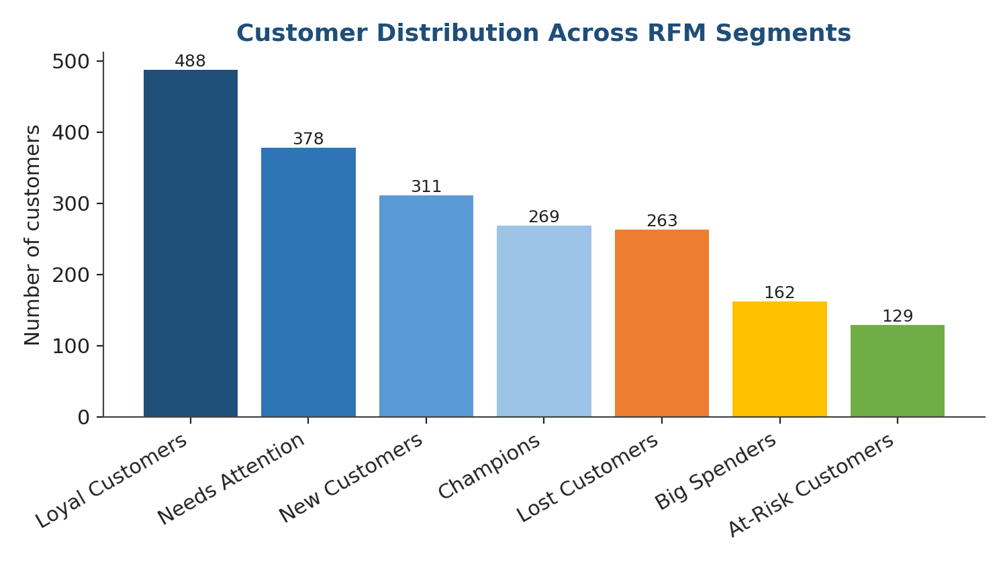
Figure 1. Customer distribution across the seven RFM segments.

5.2 Segment profile summary
The table below summarizes the key behavioral metrics for each segment, sorted by average monetary value.
Segment | Customers (% of base) | Avg. Recency (days) | Avg. Frequency | Avg. Monetary | Avg. Order Value | Cart Abandon. Rate
Champions | 269 (13.4%) | 9.9 | 5.5 | $298.73 | $55.77 | 56%
Loyal Customers | 488 (24.4%) | 61.7 | 5.2 | $250.28 | $48.30 | 63%
Big Spenders | 162 (8.1%) | 41.5 | 2.4 | $161.39 | $69.86 | 73%
New Customers | 311 (15.6%) | 10.7 | 1.0 | $50.89 | $46.82 | 66%
Needs Attention | 378 (18.9%) | 31.6 | 1.6 | $68.57 | $46.37 | 64%
At-Risk Customers | 129 (6.4%) | 89.2 | 2.3 | $76.07 | $35.64 | 67%
Lost Customers | 263 (13.2%) | 84.8 | 0.9 | $44.17 | $43.38 | 71%

5.3 Recency and monetary value relationship
Plotting each customer's recency against their monetary value shows clear separation between segments: Champions and Loyal Customers cluster toward the left of the chart (low recency, meaning a recent purchase) with a wide spread of spend, while Lost and At-Risk customers cluster toward the right (high recency, meaning a long time since last purchase) with consistently lower spend.
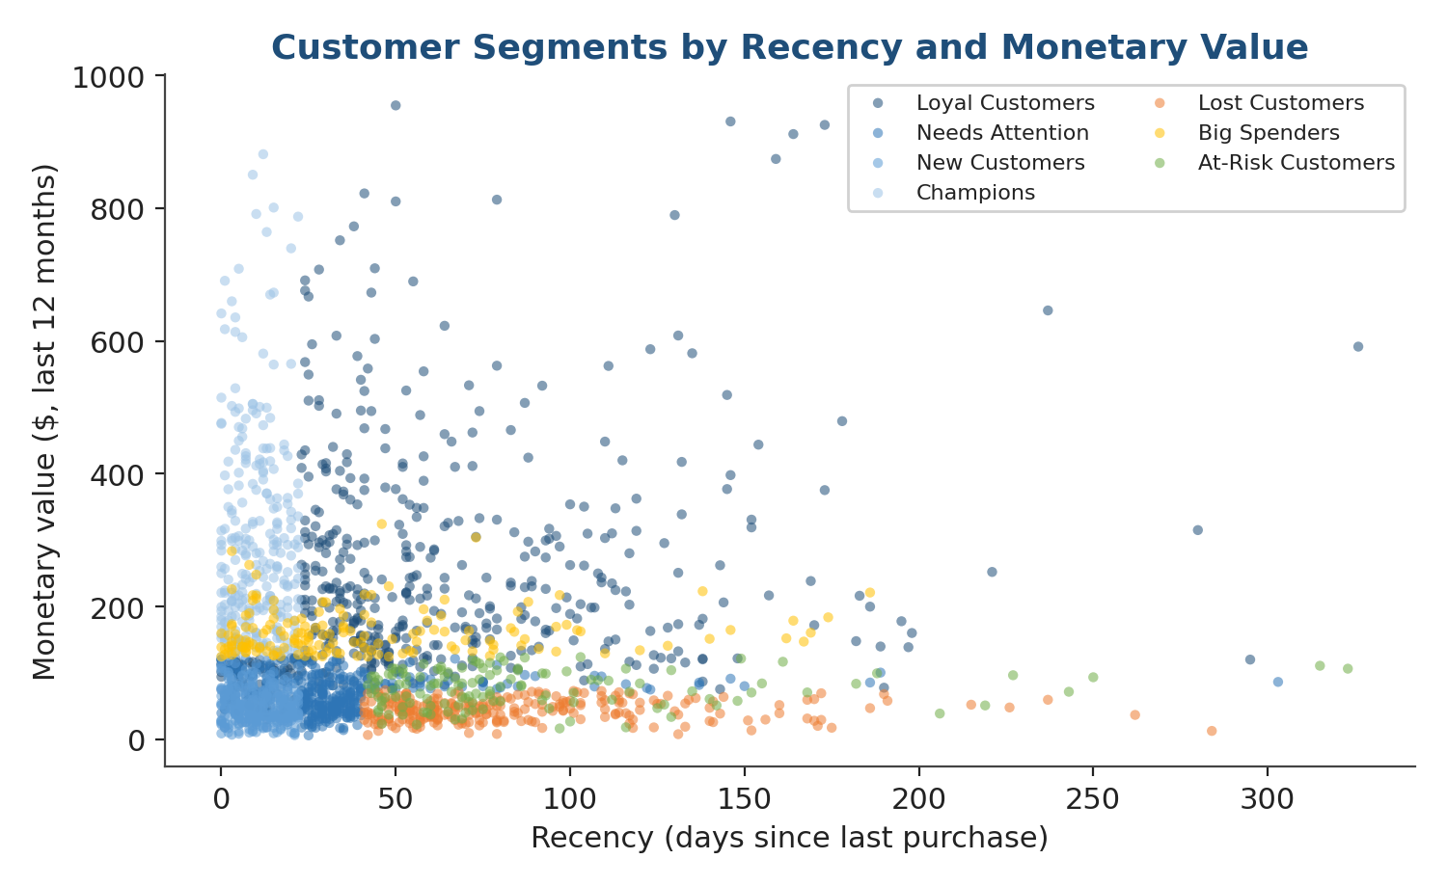
Figure 2. Customer segments plotted by recency and monetary value.

5.4 Average order value by segment
Big Spenders show the highest average order value ($69.86) despite purchasing less frequently than Loyal Customers or Champions — consistent with a segment that buys in fewer, larger transactions rather than habitually. At-Risk Customers show the lowest average order value ($35.64), which combined with their high recency suggests both declining engagement and declining basket size.
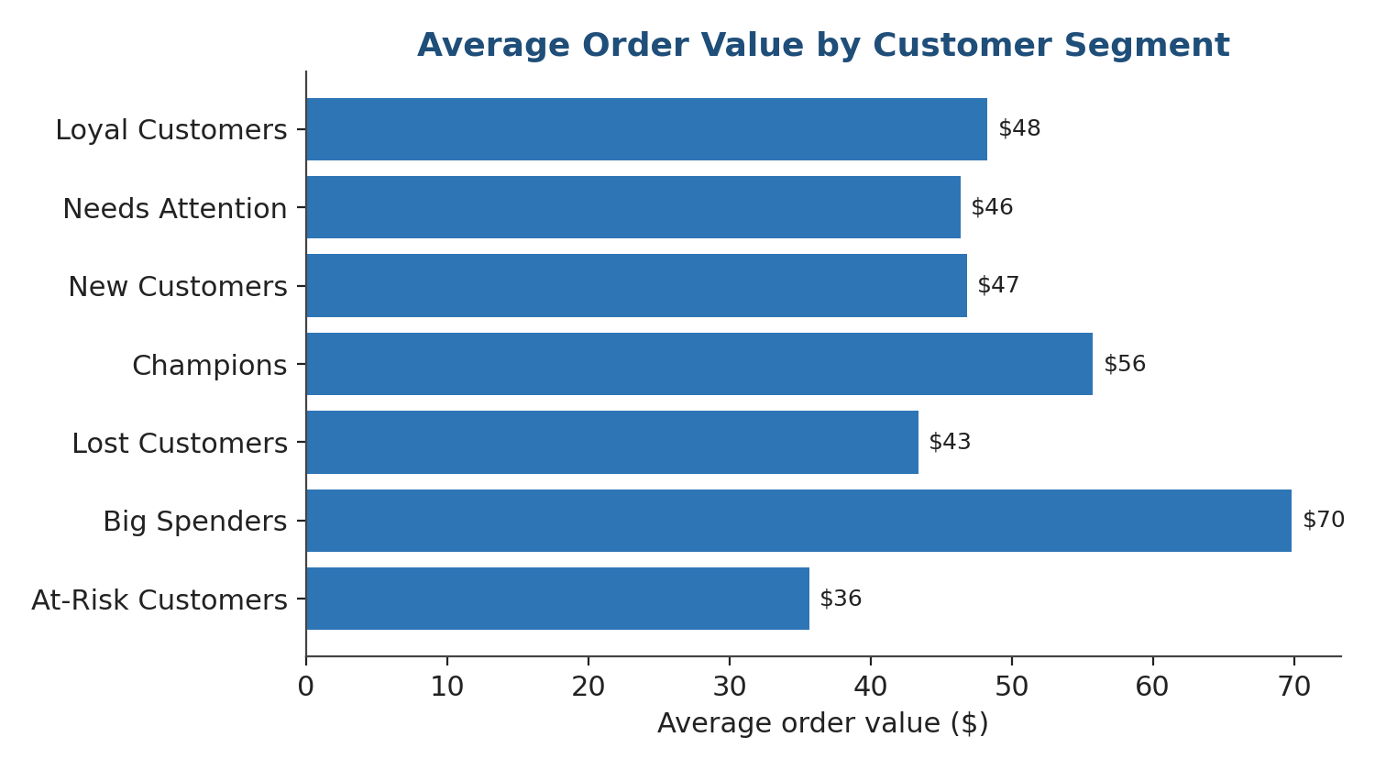
Figure 3. Average order value across customer segments.

5.5 Behavioral clustering cross-check
The independent K-Means clustering model grouped customers into four clusters that broadly mirror the RFM structure: a High-Value Engaged group (29.8% of customers, closely aligned with Champions and top-tier Loyal Customers), a High-Value At-Risk group (13.0%), a large Occasional Shoppers group (44.5%), and a smaller Dormant / Low-Engagement group (12.7%). The overlap between this unsupervised result and the rule-based RFM segments supports the validity of the segmentation approach.
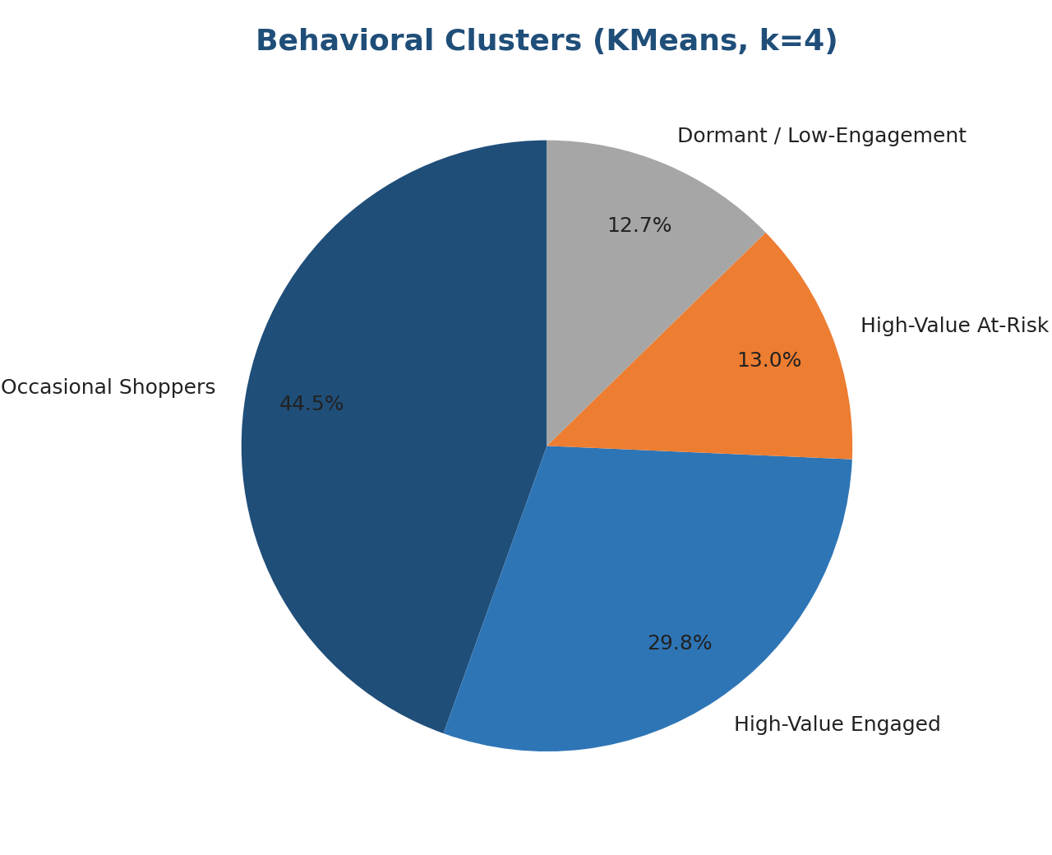
Figure 4. Behavioral clusters identified by K-Means (k = 4), independent of RFM scoring rules.

5.6 Cart abandonment by segment
Cart abandonment varies meaningfully by segment. Champions show the lowest abandonment rate (56%), noticeably below the Baymard industry benchmark of 70.22%, while Big Spenders (73%) and Lost Customers (71%) exceed it. This pattern is consistent with the premise that engagement reduces avoidable checkout friction, and suggests that abandonment-reduction efforts (e.g., simplified checkout, cart-reminder emails) would have the greatest relative impact on Big Spenders and Lost Customers.
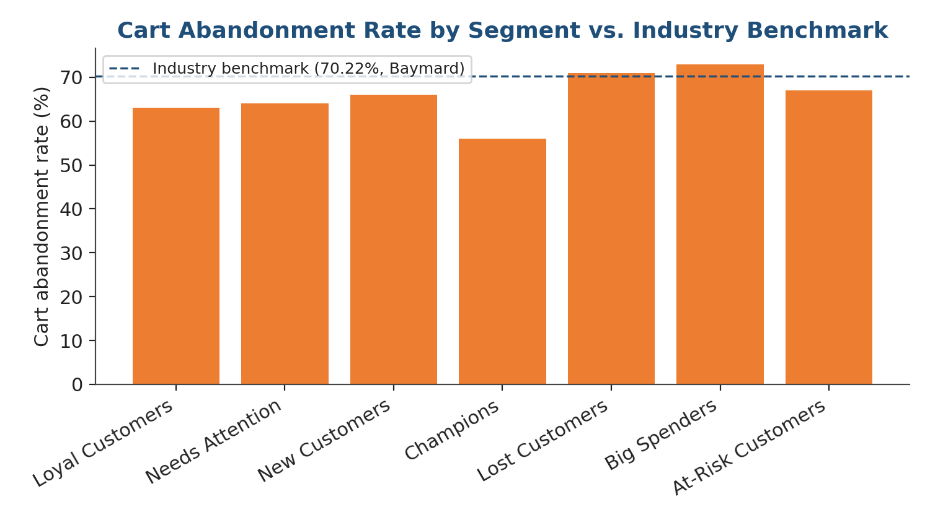
Figure 5. Cart abandonment rate by segment against the Baymard industry benchmark.

5.7 Acquisition channel mix
Organic Search (28%) and Paid Search (22%) together account for half of all customer acquisition, followed by Social Media (19%), Direct (13%), Email (12%), and Referral (7%). This mix is broadly consistent with typical retail eCommerce acquisition patterns and provides a starting point for evaluating channel-level customer quality in future analysis.
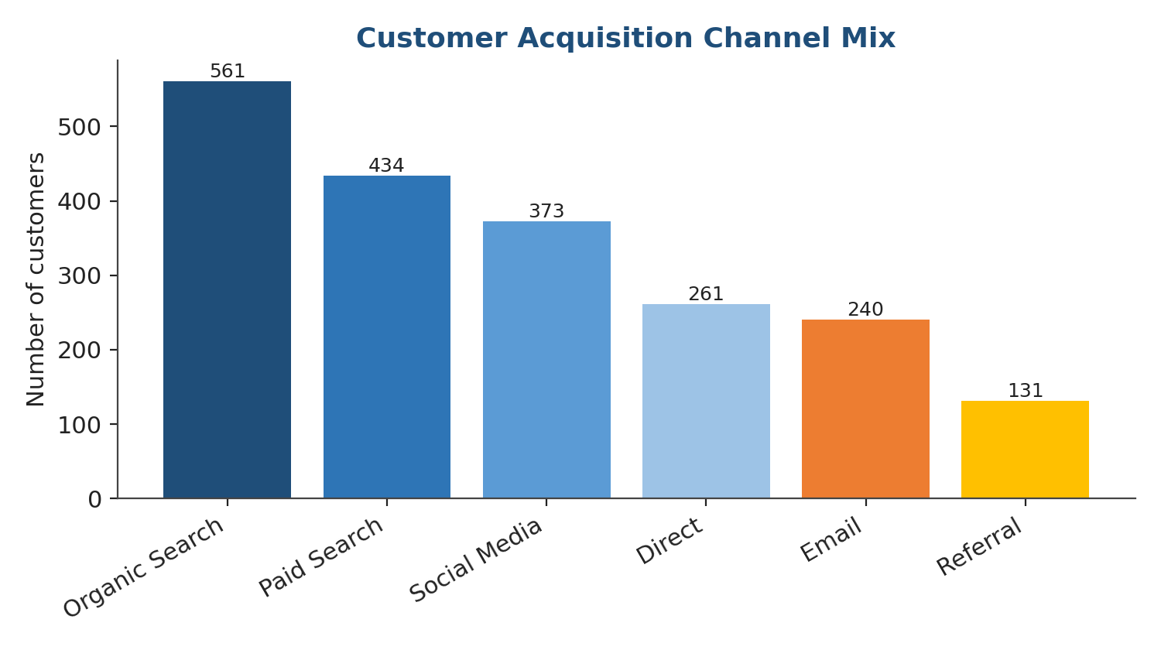
Figure 6. Distribution of customers by acquisition channel.

6. Segment Profiles and Interpretation

6.1 Champions (13.4% of customers)
Recent, frequent, high-value buyers with the lowest cart abandonment rate in the base. This is the smallest segment by count but the strongest by engagement quality, and typically the most profitable per customer.

6.2 Loyal Customers (24.4% of customers)
The largest segment. Regular repeat purchasers with solid spend, but recency is higher than Champions, indicating slightly less frequent recent activity. This group is the backbone of predictable revenue.

6.3 Big Spenders (8.1% of customers)
High average order value but lower purchase frequency — customers who buy in fewer, larger transactions. Highest cart abandonment rate of any segment, suggesting checkout friction may be disproportionately costing high-value orders.

6.4 New Customers (15.6% of customers)
Recently acquired customers whose purchase history is still forming. Low frequency and monetary value are expected at this stage; the key question is whether they convert into Loyal Customers or drift toward Needs Attention.

6.5 Needs Attention (18.9% of customers)
Customers with moderate scores across all three RFM dimensions. Neither clearly engaged nor clearly lapsed, this segment can move in either direction and represents the largest opportunity for proactive intervention.

6.6 At-Risk Customers (6.4% of customers)
Previously frequent customers showing early signs of disengagement — high recency combined with historically moderate frequency. Below-average order value suggests declining engagement precedes declining basket size.

6.7 Lost Customers (13.2% of customers)
Low recent activity and low historical value. The second-highest cart abandonment rate in the base. Win-back economics should be evaluated carefully for this group given its historically lower value.

7. Marketing Strategy Recommendations
Each segment warrants a distinct marketing approach. The table below links each segment to a primary strategic goal and concrete tactics, following the principle established in the Week 1 strategy document that every analytical finding should connect to a measurable business action.
Segment | Strategic goal | Suggested tactics
Champions | Reward and retain | Early access to new products, loyalty tier upgrades, referral incentives
Loyal Customers | Deepen engagement | Personalized cross-sell recommendations, loyalty program enrollment
Big Spenders | Reduce checkout friction | Simplified checkout, saved payment methods, abandoned-cart recovery emails
New Customers | Onboard and convert | Welcome series, second-purchase discount, product education content
Needs Attention | Re-engage proactively | Personalized offers based on past category preference, engagement-triggered emails
At-Risk Customers | Win-back campaign | Time-limited incentive, satisfaction survey to identify friction points
Lost Customers | Selective reactivation | Low-cost reactivation email; suppress from paid acquisition spend if unresponsive

7.1 Prioritization
Given limited marketing resources, the highest-priority actions are: (1) protecting Champions and Loyal Customers, who together represent 37.8% of the base and the strongest engagement; (2) reducing checkout friction for Big Spenders, where the abandonment rate is highest relative to order value at stake; and (3) proactively engaging the Needs Attention segment before customers drift into At-Risk or Lost status, since retention is consistently more cost-effective than reactivation.

8. Limitations of the Simulated Approach
- The dataset is simulated, not observed — relationships between variables (e.g., recency and abandonment) were deliberately modeled to be directionally realistic but are not derived from an actual customer base.
- Simulated data does not capture real-world complexity such as seasonality, promotional effects, or category-specific purchase cycles.
- RFM segment thresholds were set using quantiles of this simulated dataset; a production implementation would recalibrate thresholds against the business's own historical data and revisit them periodically.
- K-Means clustering assumes roughly spherical, similarly-sized clusters and requires the number of clusters (k) to be chosen in advance; alternative methods (e.g., hierarchical clustering) could be explored to validate the choice of k = 4.
- The framework does not yet incorporate product-level or channel-level interaction effects, which a fuller implementation with real transactional data would include.

9. Conclusion and Key Insights
This task demonstrates a complete customer segmentation workflow for a retail eCommerce platform: researching established segmentation methodologies, designing an RFM-based framework with clear scoring rules, simulating a realistic 2,000-customer dataset grounded in public benchmarks, and applying both rule-based and unsupervised methods to identify seven actionable customer segments.
The analysis shows that value and engagement are concentrated: Champions and Loyal Customers make up under 38% of customers but represent the platform's most reliable revenue base, while roughly one in five customers (Needs Attention) sit at a decision point between deepening engagement and drifting toward churn. Cart abandonment, while elevated across all segments relative to Champions, is highest among Big Spenders and Lost Customers — pointing to checkout experience and win-back economics as two concrete areas for follow-up analysis.

9.1 Final recommendations
- Adopt RFM scoring as the primary, low-overhead segmentation method, recalculated on a regular cadence (e.g., monthly).
- Validate segment thresholds against real transaction data as soon as it becomes available, replacing the simulated benchmarks used here.
- Prioritize retention investment in the Needs Attention segment, where proactive engagement has the highest potential return.
- Investigate checkout-specific friction for Big Spenders given their disproportionately high cart abandonment rate.
- Use the K-Means clustering cross-check as an ongoing validation step whenever RFM segment definitions are revised.
- Track segment migration over time (e.g., Loyal Customer to At-Risk) as a leading indicator, not just static segment size.

10. References
The following publicly available sources informed the segmentation methodology and benchmark assumptions used in the simulation.
Baymard Institute — Cart abandonment statistics — https://baymard.com/lists/cart-abandonment-rate — Industry-aggregate cart abandonment benchmark (70.22%) used to anchor the simulated abandonment rates.
Google Analytics Help — Recommended events — https://support.google.com/analytics/answer/9267735?hl=en — Standard eCommerce event structure referenced for digital-behavior segmentation criteria.
UN Trade and Development (UNCTAD) — Data Insights: E-commerce — https://unctadstat.unctad.org/insights/theme/260 — Industry context on global eCommerce growth, consistent with the Week 1 strategy document.
UCI Machine Learning Repository — Online Retail II — https://archive.ics.uci.edu/dataset/502/online%2Bretail%2Bii — Reference example of real retail transaction data structure used to inform the simulated dataset's fields.
scikit-learn documentation — KMeans clustering — https://scikit-learn.org/stable/modules/generated/sklearn.cluster.KMeans.html — Clustering algorithm used for the independent behavioral segmentation cross-check.
PyPI — rfm: Python Package for RFM Analysis and Customer Segmentation — https://pypi.org/project/rfm/ — General reference for implementing RFM scoring and customer segmentation in Python.
End of Week 2 Report

